

Smart Disaster Relief Inventory and Distribution Management System using ‘C’

CSA0203 C - PROGRAMMING

PRESENTED BY:
Pavani B (192525248)

Guided by:
S k Saravanan

Smart Disaster Relief Inventory and Distribution Management System

1. Problem Statement
During natural disasters such as floods, cyclones, earthquakes, and landslides, large quantities of essential resources like food, drinking water, medicines, blankets, rescue equipment, and temporary shelters are required. Managing these resources manually can be difficult, especially when several relief centres are involved.
The Smart Disaster Relief Inventory and Distribution Management System is a menu-driven C application designed to help disaster-management authorities maintain and manage relief-resource information efficiently.
The system stores details such as resource ID, resource name, category, available quantity, minimum required quantity, distribution centre, and priority level. It allows the administrator to add, update, search, sort, and merge resource records from different centres.
The system also checks the availability of resources and classifies them as Adequate, Low, or Critical. This helps authorities quickly identify resources that need immediate replenishment.
The project demonstrates important C programming concepts including operators, decision-making, loops, arrays, strings, searching, sorting, functions, pointers, recursion, and file handling.

2. Objectives
The main objectives of this project are:
- To develop a simple C-based system for managing disaster-relief resources.
- To maintain information about food, water, medicines, blankets, equipment, and shelters.
- To allow administrators to add, update, delete, and search resource records.
- To sort resources based on quantity, priority, category, and distribution centre.
- To merge resource information received from different relief centres.
- To identify duplicate resource IDs during merging.
- To classify resources as Adequate, Low, or Critical.
- To identify resources that require immediate replenishment.
- To store and retrieve resource information using files.
- To demonstrate functions, pointers, recursion, arrays, strings, and other C programming concepts.

3. Requirements and Environment Used

Hardware Requirements
- Computer/Laptop
- Minimum 4 GB RAM
- Minimum 500 MB free storage
- Keyboard and monitor

Software Requirements
- Operating System: Windows/Linux
- Programming Language: C
- Compiler: GCC / MinGW
- IDE: Code::Blocks / Visual Studio Code / Dev-C++ / Turbo C
- File format: .txt or .dat

Concepts Used
- Variables and constants
- Operators
- if-else and switch
- for, while, and do-while loops
- Arrays
- Strings
- Structures
- Functions
- Pointers
- Recursion
- Searching
- Sorting
- File handling

4. Design / Proposed Solution
The proposed system works through a menu-driven interface. When the program starts, the administrator is shown different options.

Main Menu
========== DISASTER RELIEF MANAGEMENT SYSTEM ==========

1. Add Resource
2. Display Resources
3. Search Resource
4. Update Resource
5. Sort Resources
6. Analyse Resource Status
7. Merge Relief Centre Records
8. Generate Report
9. Save Records
10. Load Records
0. Exit

Enter your choice:7
The administrator selects an option and performs the required operation.

Resource Information
Each resource contains:
Field | Description
Resource ID | Unique identification number
Resource Name | Name of the resource
Category | Food, Water, Medicine, etc.
Quantity | Current available quantity
Minimum Required | Minimum quantity needed
Distribution Centre | Centre where resource is stored
Priority | Priority level of the resource

5. Resource Status Analysis
The system compares the available quantity with the minimum required quantity.
For example:
Available Quantity = 500
Minimum Required = 300
Since the available quantity is greater than the minimum required quantity, the resource is:
Status: ADEQUATE
A simple classification can be:
If quantity >= minimum required
ADEQUATE

If quantity < minimum required
LOW

If quantity <= 50% of minimum required
CRITICAL
This helps authorities understand which resources require immediate attention.
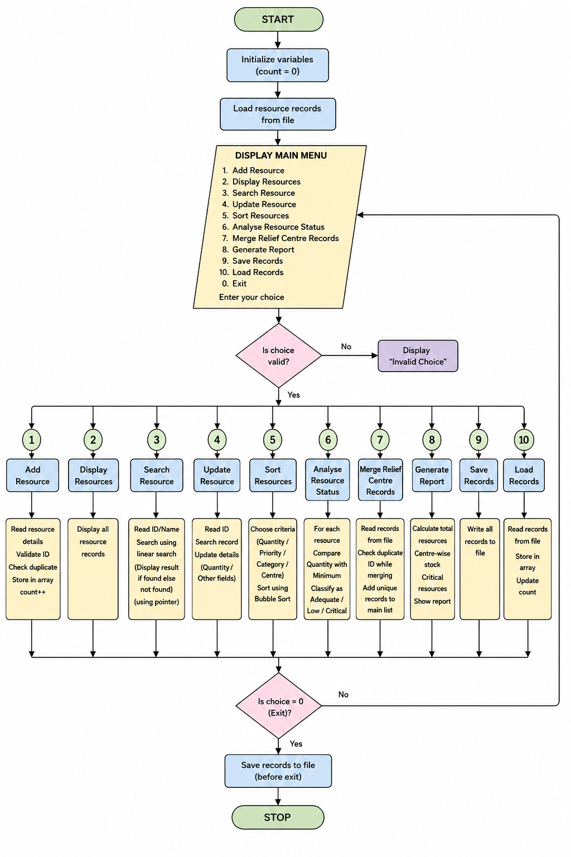
6. Algorithm
Algorithm for Adding a Resource
- Start.
- Read the resource ID.
- Check whether the ID already exists.
- If the ID exists, display "Duplicate Resource ID".
- Otherwise, read resource name and category.
- Read available quantity.
- Read minimum required quantity.
- Read distribution centre.
- Read priority level.
- Store the information in the array.
- Display successful addition message.
- Stop.
Algorithm for Searching
- Start.
- Ask the administrator for the resource ID/name.
- Compare the input with each stored record.
- If a matching record is found, display its details.
- Otherwise, display "Resource not found".
- Stop.
Algorithm for Sorting
- Start.
- Select the sorting criterion.
- Compare two resource records.
- Swap the records if they are in the wrong order.
- Repeat until all records are sorted.
- Display the sorted records.
- Stop.
7. Pseudocode
START
Load records from file
REPEAT
Display Main Menu
Read choice
IF choice = 1
Add Resource
ELSE IF choice = 2
Display Resources
ELSE IF choice = 3
Search Resource
ELSE IF choice = 4
Update Resource
ELSE IF choice = 5
Sort Resources
ELSE IF choice = 6
Analyse Resource Status
ELSE IF choice = 7
Merge Centre Records
ELSE IF choice = 8
Generate Report
ELSE IF choice = 9
Save Records
ELSE IF choice = 10
Load Records
ELSE IF choice = 0
Exit
ELSE
Display "Invalid Choice"
UNTIL choice = 0
END

8. C Program Implementation
Here is a simple working version that demonstrates the major concepts required in the question.
#include <stdio.h>
#include <string.h>

#define MAX 100

struct Resource
{
int id;
char name[50];
char category[30];
int quantity;
int minimum;
char centre[40];
int priority;
};

struct Resource r[MAX];
int count = 0;

/* Function to find resource using pointer */
int searchResource(int id)
{
struct Resource *p = r;

for (int i = 0; i < count; i++, p++)
{
if (p->id == id)
return i;
}

return -1;
}

/* Recursive function to calculate total quantity */
int totalQuantity(int index)
{
if (index == count)
return 0;

return r[index].quantity + totalQuantity(index + 1);
}

/* Add resource */
void addResource()
{
int id;

printf("\nEnter Resource ID: ");
scanf("%d", &id);

if (searchResource(id) != -1)
{
printf("Resource ID already exists!\n");
return;
}

r[count].id = id;

printf("Enter Resource Name: ");
scanf(" %[^\n]", r[count].name);

printf("Enter Category: ");
scanf(" %[^\n]", r[count].category);

printf("Enter Available Quantity: ");
scanf("%d", &r[count].quantity);

printf("Enter Minimum Required Quantity: ");
scanf("%d", &r[count].minimum);

printf("Enter Distribution Centre: ");
scanf(" %[^\n]", r[count].centre);

printf("Enter Priority (1-High, 2-Medium, 3-Low): ");
scanf("%d", &r[count].priority);

count++;

printf("\nResource added successfully!\n");
}

/* Display resources */
void displayResources()
{
if (count == 0)
{
printf("\nNo resources available.\n");
return;
}

printf("\n================ RESOURCE DETAILS ================\n");

for (int i = 0; i < count; i++)
{
printf("\nResource ID : %d", r[i].id);
printf("\nResource Name : %s", r[i].name);
printf("\nCategory : %s", r[i].category);
printf("\nQuantity Available: %d", r[i].quantity);
printf("\nMinimum Required : %d", r[i].minimum);
printf("\nDistribution Centre: %s", r[i].centre);
printf("\nPriority : %d\n", r[i].priority);
}
}

/* Search resource */
void search()
{
int id;

printf("\nEnter Resource ID to search: ");
scanf("%d", &id);

int pos = searchResource(id);

if (pos == -1)
{
printf("Resource not found.\n");
}
else
{
printf("\nResource Found!\n");
printf("ID : %d\n", r[pos].id);
printf("Name : %s\n", r[pos].name);
printf("Category : %s\n", r[pos].category);
printf("Quantity : %d\n", r[pos].quantity);
printf("Centre : %s\n", r[pos].centre);
}
}

/* Update quantity */
void updateResource()
{
int id, quantity;

printf("\nEnter Resource ID: ");
scanf("%d", &id);

int pos = searchResource(id);

if (pos == -1)
{
printf("Resource not found.\n");
return;
}

printf("Current Quantity: %d\n", r[pos].quantity);

printf("Enter New Quantity: ");
scanf("%d", &quantity);

if (quantity < 0)
{
printf("Quantity cannot be negative.\n");
return;
}

r[pos].quantity = quantity;

printf("Resource updated successfully.\n");
}

/* Sort by quantity */
void sortByQuantity()
{
struct Resource temp;

for (int i = 0; i < count - 1; i++)
{
for (int j = 0; j < count - i - 1; j++)
{
if (r[j].quantity > r[j + 1].quantity)
{
temp = r[j];
r[j] = r[j + 1];
r[j + 1] = temp;
}
}
}

printf("\nResources sorted by quantity.\n");
}

/* Analyse stock */
void analyse()
{
printf("\n========== RESOURCE STATUS ==========\n");

for (int i = 0; i < count; i++)
{
printf("%s : ", r[i].name);

if (r[i].quantity <= r[i].minimum / 2)
{
printf("CRITICAL - Immediate Replenishment Required\n");
}
else if (r[i].quantity < r[i].minimum)
{
printf("LOW - Replenishment Required\n");
}
else
{
printf("ADEQUATE\n");
}
}
}

/* Save records to file */
void saveToFile()
{
FILE *fp;

fp = fopen("relief_resources.txt", "w");

if (fp == NULL)
{
printf("File cannot be opened.\n");
return;
}

for (int i = 0; i < count; i++)
{
fprintf(fp, "%d|%s|%s|%d|%d|%s|%d\n",
r[i].id,
r[i].name,
r[i].category,
r[i].quantity,
r[i].minimum,
r[i].centre,
r[i].priority);
}

fclose(fp);

printf("\nRecords saved successfully.\n");
}

/* Generate report */
void report()
{
printf("\n========== DISASTER RESOURCE REPORT ==========\n");

printf("Total Resource Records : %d\n", count);

printf("Total Quantity Available: %d\n",
totalQuantity(0));

printf("\nResources Requiring Attention:\n");

for (int i = 0; i < count; i++)
{
if (r[i].quantity <= r[i].minimum)
{
printf("- %s at %s\n",
r[i].name,
r[i].centre);
}
}
}

/* Main function */
int main()
{
int choice;

do
{
printf("\n\n==============================================");
printf("\n SMART DISASTER RELIEF MANAGEMENT SYSTEM");
printf("\n==============================================");

printf("\n1. Add Resource");
printf("\n2. Display Resources");
printf("\n3. Search Resource");
printf("\n4. Update Resource");
printf("\n5. Sort by Quantity");
printf("\n6. Analyse Resource Status");
printf("\n7. Generate Report");
printf("\n8. Save Records");
printf("\n0. Exit");

printf("\n\nEnter your choice: ");
scanf("%d", &choice);

switch (choice)
{
case 1:
addResource();
break;

case 2:
displayResources();
break;

case 3:
search();
break;

case 4:
updateResource();
break;

case 5:
sortByQuantity();
break;

case 6:
analyse();
break;

case 7:
report();
break;

case 8:
saveToFile();
break;

case 0:
printf("\nThank you!\n");
break;

default:
printf("\nInvalid choice!\n");
}

} while (choice != 0);

return 0;
}

9. Sample Test Cases
Test Case | Input | Expected Result | Actual Result
TC01 | Add new resource ID 101 | Resource added | Resource added successfully
TC02 | Add ID 101 again | Duplicate ID warning | Duplicate ID detected
TC03 | Search ID 101 | Display resource details | Details displayed
TC04 | Search ID 999 | Resource not found | Resource not found
TC05 | Quantity = 500, Minimum = 300 | Adequate | Adequate
TC06 | Quantity = 200, Minimum = 300 | Low | Low
TC07 | Quantity = 100, Minimum = 300 | Critical | Critical
TC08 | Sort resources | Records sorted by quantity | Successfully sorted
TC09 | Save records | File created | Records saved
TC10 | Generate report | Total and critical resources displayed | Report generated

- Sample Output

==============================================
SMART DISASTER RELIEF MANAGEMENT SYSTEM
==============================================

1. Add Resource
2. Display Resources
3. Search Resource
4. Update Resource
5. Sort by Quantity
6. Analyse Resource Status
7. Generate Report
8. Save Records
0. Exit

Enter your choice: 1

Enter Resource ID: 101
Enter Resource Name: Drinking Water
Enter Category: Water
Enter Available Quantity: 500
Enter Minimum Required Quantity: 300
Enter Distribution Centre: Chennai Centre
Enter Priority (1-High, 2-Medium, 3-Low): 1

Resource added successfully!
Resource Analysis
========== RESOURCE STATUS ==========

Drinking Water : ADEQUATE
Rice Packets : LOW - Replenishment Required
Medicines : CRITICAL - Immediate Replenishment Required
Blankets : ADEQUATE
Report
========== DISASTER RESOURCE REPORT ==========

Total Resource Records : 4
Total Quantity Available: 1250

Resources Requiring Attention:
- Rice Packets at Chennai Centre
- Medicines at Tambaram Centre

11. Analysis and Discussion
The proposed system provides a simple way to manage disaster-relief resources using C programming. Instead of maintaining resource information manually, administrators can store the information in the program and perform different operations quickly.
Arrays and structures are used to maintain multiple resource records. Searching helps administrators find a particular resource, while sorting makes it easier to arrange resources based on their available quantity.
Decision-making statements are used to identify whether a resource is adequate, low, or critical. Loops allow the system to process multiple records without repeatedly writing the same code.
Functions divide the program into smaller modules such as adding, searching, updating, sorting, analysing, saving, and reporting. Pointers are used while accessing resource records, and recursion is demonstrated for calculating the total quantity.
File handling allows the resource information to be stored permanently. Therefore, the data does not have to be entered again every time the program is executed.

12. CO Mapping
Course Outcome | Implementation in Project
CO2 | Operators, if-else, switch, loops, validation and stock-level decisions
CO3 | Arrays, strings, searching and sorting of resource records
CO5 | Functions, structures, pointers, recursion and file handling

Bloom's Taxonomy
L4 – Analyse:
The system analyses stock levels and identifies low and critical resources.
L5 – Evaluate/Create:
The system creates a complete inventory and distribution-management solution using different C programming concepts.

13. SDG Mapping
SDG 1 – No Poverty
Proper distribution of essential relief materials can help affected people receive basic necessities during disasters.
SDG 2 – Zero Hunger
The system can help authorities monitor food packets and other essential supplies and identify shortages.
SDG 11 – Sustainable Cities and Communities
Efficient disaster-resource management improves the ability of communities to respond to natural disasters.

14. Individual Contribution of Group Members
You can modify this according to your actual group.
Member | Contribution
Member 1 | Problem analysis and requirement collection
Member 2 | C programming and menu design
Member 3 | Searching, sorting and resource analysis
Member 4 | File handling, testing and report preparation

15. Conclusion
The Smart Disaster Relief Inventory and Distribution Management System using C provides a basic but useful solution for managing disaster-relief resources. It helps administrators maintain resource records, search and sort information, identify shortages, generate reports, and store data permanently.
The project also provides practical implementation of important C programming concepts such as decision-making, loops, arrays, strings, structures, searching, sorting, functions, pointers, recursion, and file handling.
Overall, the system can help disaster-management teams make faster decisions about resource availability and replenishment, especially when multiple distribution centres are involved.

16. References
- E. Balagurusamy, Programming in ANSI C, McGraw Hill.
- Brian W. Kernighan and Dennis M. Ritchie, The C Programming Language.
- C programming concepts – arrays, functions, pointers and file handling.
- Disaster management and emergency resource-management concepts.

17. One-Page Write-up
Smart Disaster Relief Inventory and Distribution Management System using C
Natural disasters such as floods, cyclones, earthquakes, and landslides can create a sudden need for essential resources. Food, drinking water, medicines, blankets, rescue equipment, and temporary shelters have to be distributed quickly to affected people. Managing these resources manually can lead to errors, delays, duplicate records, and shortages. To solve this problem, we propose a Smart Disaster Relief Inventory and Distribution Management System using C.
The main purpose of this project is to provide a simple computer-based system for maintaining and analysing disaster-relief resources. The system stores important information such as resource ID, resource name, category, available quantity, minimum required quantity, distribution centre, and priority level. Administrators can add new resources, update existing records, search for resources, sort them based on different criteria, and generate reports.
One of the important features of the system is resource-status analysis. The available quantity is compared with the minimum required quantity. Based on the result, the system classifies a resource as Adequate, Low, or Critical. Critical resources are highlighted so that authorities can arrange replenishment immediately. This can help reduce the possibility of essential resources becoming unavailable during emergency situations.
The project uses several important concepts from C programming. Arrays and structures are used to store multiple resource records, while strings are used for resource names, categories, and distribution-centre names. Searching and sorting algorithms are implemented to locate and organise resource information. Functions are used to divide the program into smaller modules, making the application easier to understand and maintain. Pointers are used for efficient access to resource records, and recursion is demonstrated for selected calculations. File handling is used to save resource information permanently and retrieve it when required.
The application follows a menu-driven approach, making it easy for administrators to interact with the system. It also validates inputs such as resource IDs and quantities to avoid incorrect records. The system can combine information from different relief centres while checking for duplicate resource IDs.
This project is mapped to SDG 1 – No Poverty, SDG 2 – Zero Hunger, and SDG 11 – Sustainable Cities and Communities, because efficient management and distribution of emergency resources can support people affected by disasters and improve community preparedness.
In conclusion, the proposed system demonstrates how fundamental C programming concepts can be combined to create a practical solution for disaster-resource management. Although the current system is designed as a basic C application, it can be further improved by adding a database, graphical interface, user authentication, online monitoring, and real-time communication between different relief centres.

